Assignment #2.01: Modes of Heat Transfer and Specific Heat
Table of some common specific heats:

- How much energy would it take to heat a 0.25 kg block of lead from 10ºC to 40ºC?

- You leave a 0.1 kg piece of Iron in a fire. Its temperature increases from 15ºC to 200ºC. How much heat does the iron absorb?

- You have an empty 3-kg pot made of aluminum. You add 4.25 x 10³ J of energy to it. What is the increase in temperature of the pot?

- You are using steam to turn a turbine to generate electricity. If 7 Kg of steam is cooled from 150ºC to 120ºC, what is the maximum amount of work can the steam do?

- A 2-gram silver bullet is shot into the air at a speed of 175 m/s. It travels in a parabolic trajectory, then hits the ground. If its initial temperature is 40ºC, what is the temperature of the bullet after it hits the ground if all its energy becomes heat?

- A block of ice is cooled from -5ºC to -15ºC. 15,000 Joules of thermal energy was removed from the block of ice. What is the mass of the ice?

- While sitting by the fireplace, Jose presents a 0.15 carat diamond to his girlfriend. She is offended that he did not get her a bigger one, and throws the diamond into the fire. The diamond absorbs 10.18 Joules of Energy, and heats up from 20ºC to 120ºC. What is the specific heat of diamond? (Hint: 1 carat = 0.0002 kg)

- You have a copper coin with a mass of 0.25 kg. Its initial temperature is 90ºC. It is dropped into 0.5 kg of 10ºC water. What is the final equilibrium temperature?

- At the US Mint, 1-kg Gold bars are rolled into sheets for making coins. As the gold is rolled, its temperature increases due to internal friction of the metal. If 14,000 Joules of energy are lost to friction, what is the temperature increase of the gold?

- What are the three main modes of heat transfer?

- What is a fluid?

- What is the main mode of heat transfer that takes place in solids?

- What is the main mode of heat transfer that takes place in fluids?

- Which mode of heat transfer does not require a medium?

- Draw the methods of heat transfer that are present in the picture below. Label each of them.
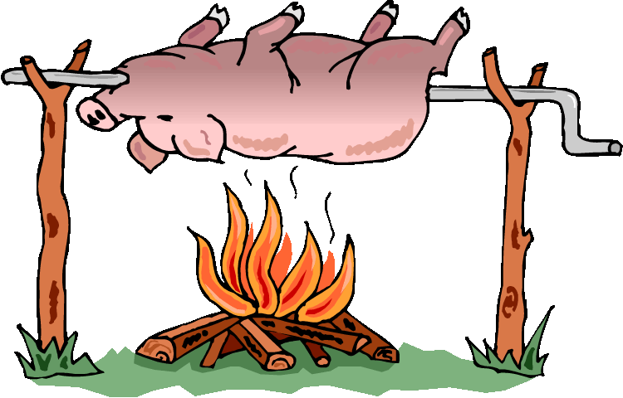

- Label the main method of heat transfer that is taking place in each situation.
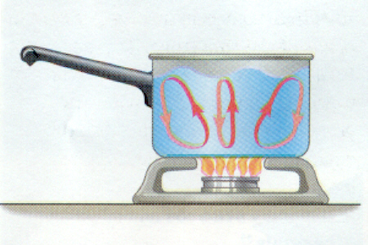
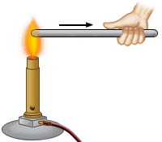
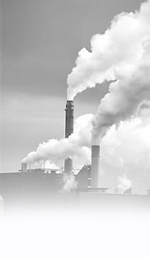
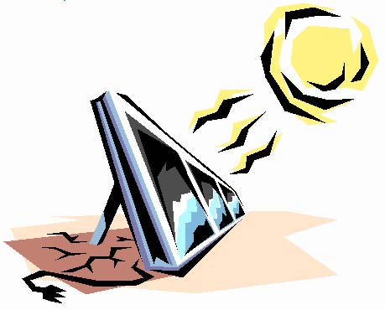

- Identify the type of heat transfer that is taking place in each situation:

______________ The sun shines on a car

______________ A pot of water begins to boil.

______________ A man cooks a hamburger on a grill.

______________ A mechanic burns himself on a hot engine.

______________ An air conditioner blows cold air.

______________ Liquid nitrogen circulates in a tank.

______________ The road heats up in the sunlight.

______________ A copper rod burns a person's hand when heated on the opposite side.

